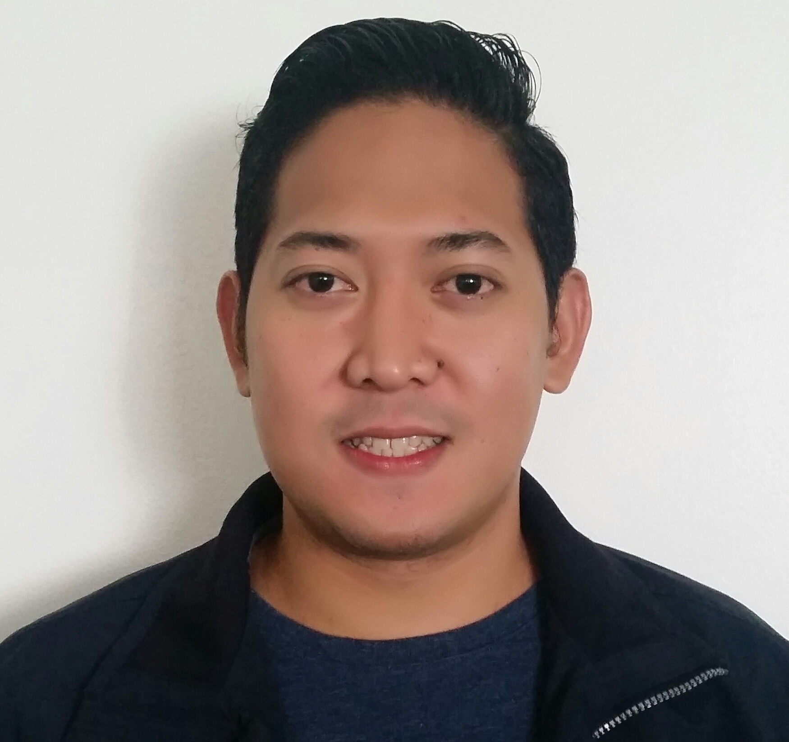
Herbert C. Cipriano
#45 A Manuel L. Quezon St. San Miguel Taguig City Philippines.
Mobile: +639476994831
Email: cipriano.herbert@gmail.com

SKILLS

Predictive and Progressive Dialer Operations and Support
Dialogic Telephony Board programming and installation
Local Area Network Setup (BPO/Call center setup; Internet Café setup)
Server Maintenance (BPO/Call center setup; Internet Café setup)
Hardware and Software installation and configuration (BPO/Call center setup; Internet Café setup)
Telephone installation and Cabling
PC Troubleshooting and Maintenance
VOIP setup and configuration
Managing Sophos Antivirus
Maintaining CCTV Cameras
Basic knowledge in Adobe Photoshop
Basic knowledge in Citrix system
Basic AVAYA setup and configuration

WORK EXPERIENCE

Software Quality Assurance (Consultant) January 2021-Present

Duties & Responsibilities:

- Quality Assurance Testing of the following applications:
-Production Line System
-Billing and Collection

IT Analyst II/QA Specialist (Consultant) September 2020 – December 2020
EVOCOMM Philippines Inc.
Paranaque City, Metro Manila

Duties & Responsibilities:
- VOIP Set up and configuration
- Remote Desktop
- Hardware and software installation
- Daily task documentation
- Quality Assurance Testing of the following applications:
-People Counting Software
-Immigration System

Desktop Support Specialist July 2020 - August 2020
Millennium Technology Services Group Philippines, Inc.
Clark Freeport Zone, Pampanga

Duties & Responsibilities:
- Handling Clusters
- Manage the team for the all projects like Upgrading OS, Assigning Tickets, Machines transfer, installation and upgrading of software’s
- Coordinating and attending all the projects with the SBU’s and assists them up to the end of the projects
- Creating Groups and User using Active Directory
- Hardware and software installation
- Completing of Ticketing Systems
- Daily task documentation
- Updating McAfee Antivirus (EPO)
- Setting up Microsoft Exchange
- Avaya Set up
- Answering local calls
- Remote desktop

IT Analyst II February 2015 - June 2020
Conduent Business Services Philippines, Inc.
MOA Complex, Pasay City

Duties & Responsibilities:
- Handling Clusters
- Attending for Bu’s CISO Compliance
- Manage the team for the all projects like Upgrading OS, Assigning Tickets, Machine’s transfer, installation and upgrading of software’s.
- Coordinating and attending all the projects with the SBU’s and assists them up to the end of the projects
- Creating Groups and User using Active Directory
- Hardware and software installation
- Completing of Ticketing Systems
- Daily task documentation
- Updating McAfee Antivirus (EPO)
- Setting up Microsoft Exchange
- Avaya Set up
- Answering local calls
- Remote desktop

IT Consultant November 2012 - January 2015
Unitech Electronics & Security System Inc.
1229 U.N Ave. Paco, Manila

Global Infrastructure Support December 2012 - October 2013
Ubiquity Global Services
BGC, Taguig City

Site IT Helpdesk December 2011 - December 2012
DTSI Group
One World Tower, Taguig City

IT Support Specialist August 2010 – November 2011
Purity Software Inc.
Valero Plaza, Makati City

IT Support Specialist April 2010 - July 2010
Infometrix. Inc. Com
Julia Vargas Ave. Ortigas Center, Pasig City

IT Support Specialist November 2009 - March 2010
Emerio Philippines
Meralco Ave Ortigas Center, Pasig City

IT Network Administrator September 2008 - October 2009
Chioma Corporation
Taft Ave. Manila

IT Support Specialist August 2007 - August 2008
Pertinacious Corp.
Ayala Ave. Makati City

IT Administrator March 2007 - July 2007
Global E-Business
West Avenue, Quezon City

Technical Support Specialist May 2004 - March 2007
Megacall, Inc.
Ayala Ave. Makati City

Service Crew July 2001 - June 2004
Mcdonald’s Corporation
Guadalupe Makati City

EDUCATION

Computer Hardware Technology and Network June 2002 - April 2004
Datamex Institute of Computer Technology

Bartender Training Course, Certified Barista April 2009 - May 2009
Technical Education and Skills Development Authority

Web Developer October 2012 - December 2012
WordPress

Frontline Leadership Development Program November 2018
Pearson Professional Programs

