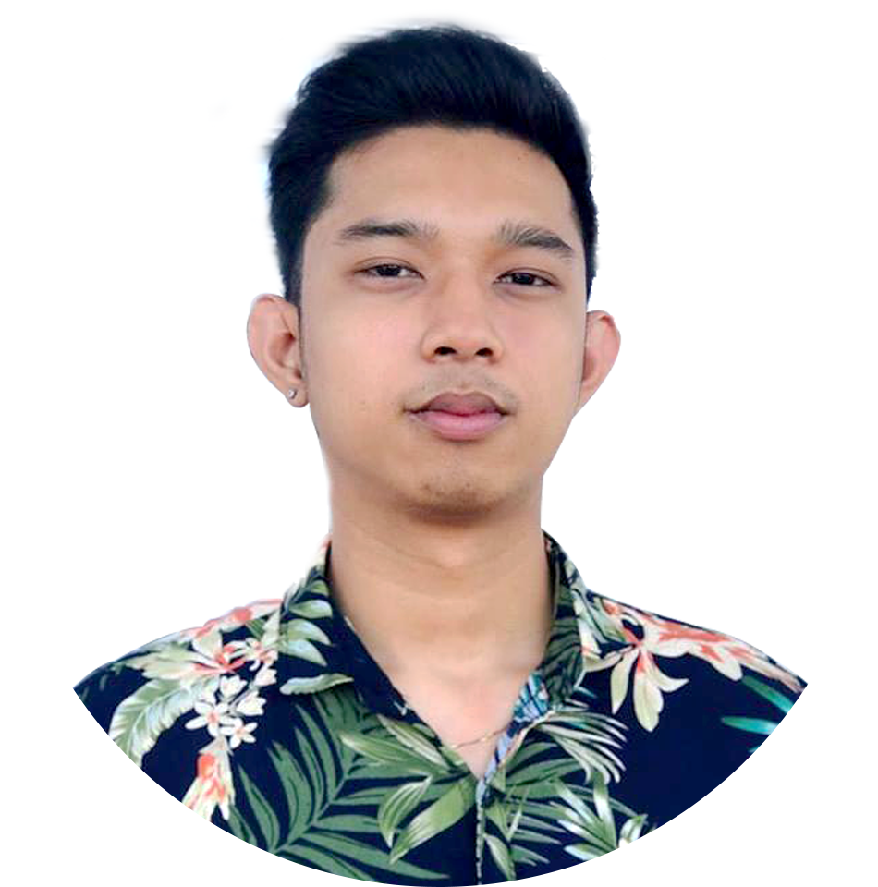 |  | Aytin, adrian ace c.  Web Developer
Profile  Goal-oriented Web Developer with strong commitment to collaboration and solutions-oriented problem-solving. Use various web design software to develop customer-focused websites and designs. Committed to high standards of web design, user experience, usability and speed for multiple types of end-users. Successful at maintaining customer satisfaction through effective customer support.  Contact  PHONE:  09958770062  EMAIL:  acey2124@gmail.com  PROJECTS  (Frontend)  - Loading System  - Accomodation Reservation System (An Airbnb like system)  - Ticketing/Book Flights System  - Online Store System (An Lazada or Shopee like system)  (Fullstack)  - Delivery App |  | EDUCATION  Bachelor of Science in Information Technology  Major in Mobile and Web Application  Trinity University of Asia  Cathedral Heights, 275 E. Rodriguez Sr. Avenue, New Manila, Quezon City, Metro Manila  2014 - 2018  WORK EXPERIENCE  Ecashpay Asia  Web Developer  10/2018 - Present  - Designed, implemented and monitored web pages and sites for continuous improvement.  - Tested websites and performed troubleshooting prior to deployment.  - Develop new user-facing features.  - Ensure the technical feasibility of UI/UX designs.  - Optimizing web pages for maximum speed and scalability.  - Collaborate with back-end developers to consume APIs and web designers to improve usability.  SKILLS  - React JS  - Node JS  - Express  - Redux  - SASS  - Frontend  - Backend  References  Arnan Nigel D. Pajarillo Merson F. Antonio  09551902524 09171606317  andpajarillo@gmail.com antonio.merson08@gmail.com

