Equipment Issue Form

Name: Ralph Ryan Aspuria Olarte
Date of issuance: 1/27/2022
Location: La Union

I have received the following Equipment:

Model: Acer Aspire 5
Make: Acer
Serial Number: 14002857734

- I understand that I am being issued a equipment as a tool to facilitate my work
- I understand that I am responsible for the equipment issued to me and that I will care for the equipment in such a manner to prevent loss or damage
- The equipment issued to me is strictly for work and not for any personal matters
- In the case of any damages or abuse of the equipment, or because of my failure to follow company technology acceptable use policies, including this agreement, I understand that I will be held accountable for it
- I understand that I will return the equipment to the company upon the end of my contract

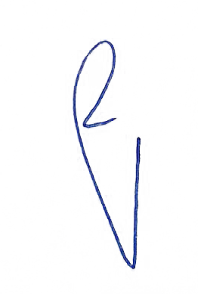
By signing this document, I am accepting and agreeing to the terms of use for this device

Ralph Ryan Olarte
_________________________________
Employee Signature over Printed Name

__2/6/2022__
Date

