JOB OFFER

Date

Name
Address Line 1
Address Line 2
Address Line 3

Dear Mr./ Ms. Last Name,

Satellite Teams, a division of Spectrum Solutions BPO, is pleased to offer you an employment opportunity under the following terms and conditions:

- Position: Put position here

- Terms of Employment:
A six (6) month probationary period unless sooner terminated or approved for regularization of employment status. You will be required to render Forty (40) regular working hours per week spread out across (5) five working days of the same week. You are entitled to work remotely for as long as you have a stable internet connection.

- Professional Status:
You are expected to devote full-time professional work for Satellite Teams, and are subject to all the defined policies and regulations of the business and the client that you are assigned to.

- Compensation and Benefits:
Compensation and Benefits is set forth in Annex A of this formal Offer of Employment.

- Conflict of Interest:
As a full-time employee of Satellite Teams, you may not engage in other business activities or fee-paying engagements that are considered to be in conflict with Satellite Teams’ or its clients’ primary interests. Any such professional engagement shall be considered as an engagement or acceptance on behalf of Satellite Teams unless otherwise discussed and approved by the company.

- Confidentiality Clause:
As a full-time employee of Satellite Teams, you shall be expected to adhere to the Non-Disclosure and Confidentiality policies of Satellite Teams and your assigned client, which require any information, consulting or training materials, programs, lists or other data that may come into your possession on account of your access thereto to be kept and used for the sole interest and benefit of Satellite Teams and your assigned client.

If the terms and conditions set forth in this formal Offer of Employment are acceptable, you shall be required to sign a formal Employment Contract based on said terms and conditions and commence probationary employment on Start Date Here. Please indicate your conformity by signing on the space provided.

ANNEX A: COMPENSATION AND BENEFITS

Gross Compensation: PHP 00,000.00 (A+B)

A. Basic Monthly Salary: PHP 00,000.00

B. Allowances
Rice Subsidy Allowance: PHP 1,500.00
Communication Allowance: PHP 1,500.00

TOTAL: PHP 3,000.00

C. 13th Month: PHP 00,000.00

D. Statutory Benefits: [SSS, HDMF and PHIC]

E. Health Card | Life Insurance Coverage:
HMO Coverage - Php 100,000.00
Life Insurance - Php 100,000.00
- HMO Health Care Benefits (Annual Physical Exam, Unlimited Consultations & Lab, Emergency with Confinement Coverage, and 24/7 Telehealth Subscription)
- Life & Accidental Death Insurance
- Dental Care
- Vision Care
- Mental Health Care

F. Leave Benefits

- You will earn 1.6 leave credits per month of engagement for a total of 20 leave credits a year.
- Leave availment can only be enjoyed upon regularization.
- For regular employees, the maximum number of consecutive days which may be availed in a six-month period is 5.
- There is no commutation of unused leave credits but a maximum of five (5) can be carried over to the following year. This should be availed within the first quarter. Application for extension of period of availment will be subject to Management approval.

==============================================================================

Noted by: Signed and Accepted by:
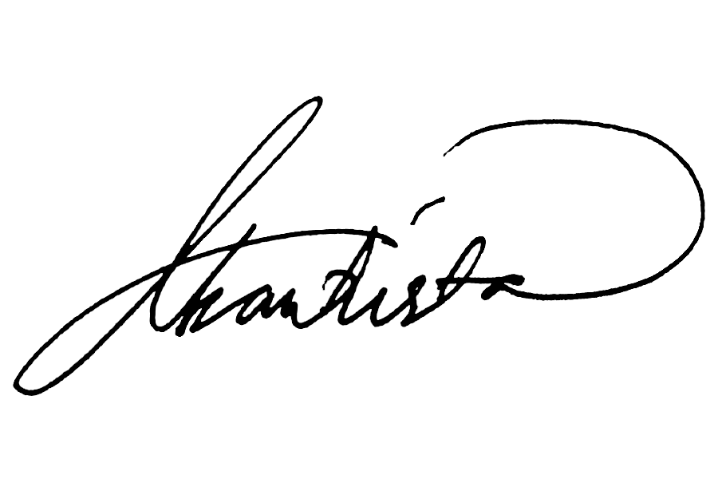 _________________________________
Mariecon S. Bautista Name of Employee
HR Director Date Signed:

EMPLOYMENT AGREEMENT

Know all men by these presents:

This agreement entered into this __ day of ____, 2022 by and between Spectrum Solutions BPO, Inc., duly organized and existing under the laws of the Philippines with office Unit 209, Amberland Plaza, Jade Drive, Ortigas Center, City of Pasig 1605 hereinafter referred to as the Company, represented in this Act by its HR Director, Mariecon S. Bautista

-and-

NAME OF EMPLOYEE, of legal age, Filipino, residing at, Address of employee; is referred to as a Probationary Employee

WITNESSETH

Work Assignment
The Company hereby engages the services of the Employee for the position of Position of Employee. The Employee accepts the terms in this Agreement, and hereby agrees to devote time, energy, and ability to the best interest of the Company and the Client to which the Employee has been assigned to in an efficient and trustworthy manner.

Probationary Period
Probationary period is six months commencing on _________ and will automatically terminate on ________ unless we notify you in writing on or before the end of this period that your services will be continued. Your conversion to permanent status will be determined by your work performance, compliance with rules and regulations, suitability for the permanent job, and compliance with operational requirements of the Company.

Training Contract
In the event that the Company provides and pays for any external training, you agree to remain in the employ of the Company for a required length of service which will be determined and set forth in a separate Training Contract. If, for any reason, you voluntarily resign from the Company before the end of the required length of service, you agree to pay the Company the damages, without prejudice to other remedies that the Company may have against you.

Salary and Compensation
For giving your time, dedication, effort and attention to the work assigned to you during the working hours of the Company, you shall be paid a Monthly Gross Salary of XX Thousand Pesos (PHP 00,000.00) which includes a Basic Pay of XX Thousand Pesos (PHP 00,000.00 ) and an Allowance of Three Thousand Pesos Only (PHP 3,000.00), Your salary is confidential and we trust that you keep the same in strict confidentiality with other employees in the Company, to your assigned Client, and the Client’s Employees.

Hours of Work
The Employee shall render forty (40) hours per week spread out across five (5) working days. The needs of the Client’s business will dictate the period of working hours. The Employee will coordinate his/ her schedule with Human Resources. Within the duration of employment, the employee must not accept or refrain from working for another employer whether within or outside working hours. Complete transparency and prior approval from Management needs to be secured otherwise.

Termination of Employment
The employee may terminate the Employment Agreement by giving a 30-day notice. A resignation letter must be sent to a.delrosario@satelliteteams.com for this purpose. Salary put on hold for services rendered for the duration of the last cut off, proportionate 13th month pay and five (5) day computation of Service Incentive Leave (if employee has rendered at least one year of service and has not used them) will form part of the employee’s last pay. Last pay will only be released once employee is cleared.

The Company in turn may terminate the Employment Agreement observing the rules of due process on the following grounds:
- Just or authorized causes as found under the Labor Code
- Violation of this Employment Agreement
- Type A Violation committed by the employee of the Code of Discipline and Ethics

Code of Discipline and Ethics
Strict compliance with Satellite Teams’ Code of Discipline and Ethics is mandatory. It will immediately be made known to the employee upon onboarding. An HR Orientation will be held to discuss the Employee Handbook for this purpose.

Confidentiality and Non-Disclosure
You agree that all records and documents of the Company, all information pertaining to its business or affairs or any of its clients and affiliated companies are confidential, and that no unauthorized disclosure or reproduction of the same will be made by you at any time during engagement and after one (1) year from disengagement with Satellite Teams. You agree that all company records, documents and assets in your custody and control shall be immediately surrendered to the Company once requested during the employment period and upon termination thereof, whether or not requested.

The employee shall not at any time or any manner, either directly or indirectly, divulge, disclose or communicate to any person, natural or juridical, in any manner whatsoever any information concerning any matters affecting or relating to the business of the Company and the Client you are assigned to, including but not limited to techniques, technology, and other systems, without regard to whether or not such matters will be deemed confidential, material or important.

Any breach of the terms of this Section is considered a material breach of this Contract and may be a ground for termination of employment.

Inventions and Ownership of Inventions
The employee agrees that all Intellectual Property Rights (if any) created or developed during the course of employment shall belong and vest solely and absolutely, legally and beneficially, with the Company or the assigned Client. The Employee will disclose promptly to the Company or the assigned Client all Intellectual Property Rights (if any) created or developed during the period of your Employment.

The Employee assigns and hereby agrees to assign to the Company or otherwise as the Company shall designate in writing, all of her rights, if any, to such Intellectual Property Rights, including but not limited to letters, patents, copyrights, trade names and trademarks for such Intellectual Property Rights.

For the purposes of this Clause, “Intellectual Property Rights” includes the full benefit (subject to the obligations) of all patents, trade and other marks, registered designs (and applications for all the same), copyrights, trade and business names, inventions, discoveries, improvements, designs, techniques, and other confidential processes and information and know-how and any licenses in connection with any of the same and full right to all intellectual property and legal protection relating to the same.

Non-Compete
You agree not to engage in any activity that is competitive with the activities of the Company during the course of employment and for a period of one (1) year after its termination.

For purposes of this clause, competitive activity encompasses being subsequently employed by the Company’s suppliers, its Clients, or any other entities engaged in business which is directly or indirectly competing with the Company’s business; doing any work not assigned by the Company for the Company’s clients or suppliers; or making plans to form a business entity that may be deemed to be competitive with the Company’s business.

You also agree that while employed, you will not seek any form of employment nor offer your services to the Company’s clients, one () year after the termination of your employment under this Contract in any manner, whether with or without cause, you will not accept any form of employment, whether contractual or regular, directly or indirectly, or in any manner be connected with any of the Company clients, unless otherwise approved in writing.

Non-Solicitation
Employees shall not, without the Company’s prior written consent, directly or indirectly solicit, induce, recruit, encourage or otherwise endeavor to cause or attempt to cause any employee or consultant of the Company to terminate his/ her employment relationship with the latter. The Employee agrees and shall pay the Company liquidated damages in the amount equivalent to one (1) year of the Employee’s Gross Salary, if found to have violated the non-solicitation provisions of this Agreement.

Entire Agreement
This agreement constitutes the entire agreement between the parties with respect to the subject matter hereof, and supersedes all prior and current arrangements whether written or oral, between the parties. Provisions may only be amended through a separate written document signed by both parties. The Employee confirms that Spectrum Solutions BPO Inc has made no other representations or warranties, expressed or implied, other than those contained in this agreement.

In witness whereof, the parties have signed this Agreement in Pasig City, Philippines on ______.

MARIECON S. BAUTISTA
Human Resources Director
==========================================

ACCEPTANCE:
I have read and understood the contents of this Agreement and I am willing to abide by the terms and conditions stated herein. I accept the position and terms of employment offered and will commence work on ____________.

Name of Employee
Date Signed:

