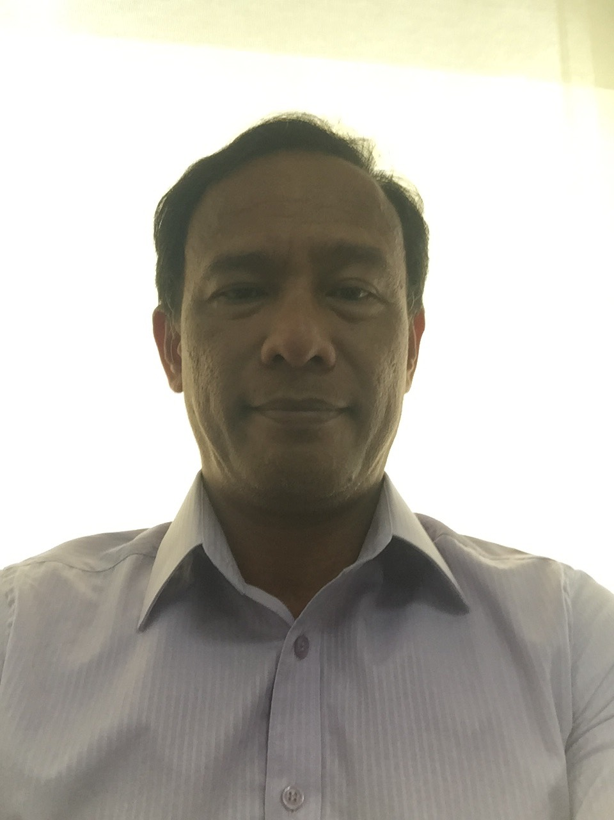

**EDSEL ANDRE J. SILO**

#19 Zambia st. Better Living , Barangay Don Bosco Paranaque

Metro Manila, Philippines 1701;

Contact Number: (632)7358.3584; (63)917.8233244;

Email Address: edselandresilo@yahoo.com

**PROFILE SUMMARY:**

Has accumulated 27 years of excellent professional reputation in DevOps/Product/Project Management, Software Development, Online Gaming, Data, Voice, IP implementation. Major responsibility is to establish a company’s business and technical vision and lead all aspects of technology development according to its strategic direction and growth objectives. This also includes building and managing the technology team on large-scale applications.

Product Management:

* Highly knowledgeable in using Agile and SDLC methodology
* Responsible for the strategy, roadmap, and feature definition for that product or product line
* Collaboration and Integration with 3rd party software companies
* Builds Business Requirements and Technical design architecture
* Aligns with Project Managers, Scrum Masters, Business users and Development Team

Programming languages:

* C# .NET, ASP.NET, MVC, WCF, Java, VB, C/C++
* PHP, HTML, CSS, JQuery and JavaScript

With vast experience on developing Telecom applications such as:

* Predictive/Progressive/Blast Voice Dialers (IP or TDM)
* Carrier peering connectivity
* Soft phones, Interactive Voice Response Units (IVR)
* Voice Mail; Auto Attendant; Callback
* Legacy/VoIP, Payment Gateways
* Soft Switch
* Asterisk (Vici, FreePBX, GoAuto)
* Mediation applications
* Mobile Applications (Voice/SMS/Video)
* Virtual Fax; Bulk SMS

Knowledgeable on:

* Carrier or Telco signaling such as Analog, E1, T1, PRI, BRI and ISDN, SIP.
* Protocols such as TCP/IP, UDP, H323, HTTP, HTTPS, FTP, SMPP, SMTP, POP3, XML, VXML, SNMP, NMAP and codecs for voice and data.
* Cloud experience using Digital Ocean, Vultr, AWS, Softlayer and Rackspce
* Data Center Technologies such as OpenStack, Docker and Virtual Machines
* Data and Call Center Networking
* Configured routers, gateways, firewalls and network security systems.

Has designed and developed programs such as:

* Call Center Applications
* Billing Engines and Platforms
* Telephony Applications (SMS, Voice, Switches, and VoIP)
* SIP/TCP/UDP/Emulations related Software
* Hotel Management Application
* Customer Relation Management (CRM)
* Accounting/Payroll/Attendance/GL
* Hotel and Room Management System (HRM)
* Web Applications and Sales and Marketing Systems
* Air Time Topup, Bills Pay, Wallet Systems
* Payment Gateways
* Network and Server monitoring tools
* API – WSDL, ASMX, SVC, REST, JSON, XML

With extensive knowledge in:

* Software and Hardware Design and Architecture using different OS platforms such as Windows,

Linux, Solaris, AIX, SCO and mobile applications for IOS, Android, Symbian and Windows Mobile.

Installed, maintained and used different kinds of Data Base Engines such as:

* MS SQL Server, MySQL, MSDE, Oracle, BTRIEVE, Cassandra, MongoDB, Redis

**PROFESSIONAL EXPERIENCE/S:**

**DevOps Manager 2019-2020**

**WTECH Solutions Inc.**

WTECH is a software development company that caters on development of software for Oriental Gaming market. Currently handling 70 developers, 32 Quality Assurance Engineers, 4 System Analysts, 3 Project Managers.

My Main objective is to organize and apply and organize the process of the DevOps team to maximize the existing resources and create a fluent flow of operations within the division.

**Technical Consultant 2017-2018**

**IPS Inc. Japan**

IPS is the holding company located at Tokyo Japan its point of presence companies are Key Square Inc., Shinagawa, Toki, Horizon, InfiniVan, Advent to name a few. IPS offers services such as voice (Legacy/VOIP), SMS, top-up (airtime), TV broadcasting, Radio broadcasting, care giving school, engineering school in Japan, Bandwidth and Beauty Services.

**Worldhub Services Inc. - Present**

**Software Product Manager, 2015 - 2017**

Located in Fort Bonifacio, Manila, Philippines, World Hub Services supplies exceptional 24/7 customer service, sales and product support to our online gaming clients. Always striving to exceed customer expectations and offering an energetic office environment, World Hub Services is proud to be a fast-growing company that encourages employee development in a friendly office atmosphere.

* Responsible in aligning business needs and technical information of a new products or projects. Make sure that integration and communication with 3rd party software are collaborated efficiently. Creates Business Requirements, technical specifications and architecture, tests cases/units/automation are delivered with quality.

**Agile Solution Partners**

**Software Product Manager, 2014 - 2015**

Headquartered in Toronto Canada since 2012, Agile Solution Partners is now present in two other countries. We are founded on a mission to deliver high quality solutions and services based on rapid development and delivery framework of the Agile principles, methods and practices.

* Main architect of all design, research, development, security and networking of Agile Solution Partners products and services. Handling programmers, network engineers and project managers to make sure all system is delivered and working.

**Advent Integra Solutions PTE, LTD.**

**Chief Technical Officer, 2012 - 2014**

Advent is a Singapore-based company that is focused on developing solutions for service providers addressing the overseas migrant worker market. Their goal is to provide a modular and unified solution that will allow service providers to provide their migrant customers value-added services to enhance their existing offerings to increase ARPU and loyalty.

* Responsible for development and integration of the following services and payment gateway ssuch as:

eLoad, BillsPay, IPTV VOD, eCommerce, EZLink, Smartpit, Merchant Account, Paypal, Ukash and others.

**Manager-Programming and Development Team, 2011 – 2012**

**iVoisys Pty Ltd**

iVoisys is a leading pioneer of integrated business technology in Australia, with its retail arm boasting more than 260,000 customers. iVoisys was formed to cater for the more sophisticated internet telephony needs of business clients.

* Re-structure and re-design all business applications that are related to telephony services and devices.

**Technology Information Manager for Worldwide Operations, 2010-2011**

**TELECALL Global Communications**

Telecall is a telecom operator that offers complete telecommunications solutions in Brazil including long distance and international calling, public phones and VOIP services since 1998. Telecall is providing reliable and high quality services, establishing trends in innovative services.

* Introduced and developed an application that would link to their existing Voice platform and market it as another Value Add Service. The services added are SMS, Top-up, Remittance, Bills Payment, Web Phone, Soft phone, Mobile and Web Contents Services.

**Technology Information Manager / IT Manager, 2003-2009**

**PIMS - Pilipinas International Marketing/ IPS – International Placement Services**

PIMS was set up in June 1999 and began operation in March of the same year. The company is focused on providing products and services to the Filipinos and other foreigners working in Japan. Today, PIMS offers a variety of products like Access Plus rechargeable card and other telephone cards and personal care products. Its services include Door-to-Door delivery and satellite TV (Access Television). PIMS also publishes the Pinoy Gazette, a bimonthly newspaper for the Filipino community in Japan.

IPS is the holding company located at Tokyo Japan its point of presence companies are PIMS, Megacall, Advent to name a few. IPS offers services such as voice (Legacy/VOIP), SMS, top-up (airtime), TV broadcasting, Radio broadcasting, care giving school, engineering school in Japan.

* Managed seven (7) programmers, two (2) Analysts, four (4) technical support, one (1) network administrator, one (1) Lead Management officer, (15) NOC both Japan and Philippines.
* Architected the Top-up (Smart), Top-up(Globe), (Top-up) system from Japan to Philippines
* Architected the Top-up (Indonesia) system from Japan to Indonesia
* Architected the Japan to Rest of the World SMS services
* Architected soft phone (on-market) development with integrated services like Chat, SMS, Top-up and web.
* Implemented SIP enabled dialer for Customer Service and Billing & Collection.
* Developed an IVR for the 24hours prepaid card hotline in Japan.
* Developed Top-up IVR to complement landline clients.
* Developed a soft phone via Web or Stand Alone
* Responsible for all Software Development and Hardware maintenance of PIMS, Mega Call, Transtech and Worlcomm Call Center.
* Making sure that all software applications help marketing and sales provide revenues by producing reports and monitoring tools in real-time.
* Consultant on Network and Gateway on the carrier division.
* Currently designing and developing Unified Messaging System that integrates all sources of communication on one application or site.

**VP-Technology & Development, 2002-2003**

**US-Asia Solutions**

US-Asia Solutions is an outbound call center with a hundred (100) seats capacity. Its campaign is mainly selling time-share.

* Developed the Predictive Dialer for call center application. The system can function as outbound, inbound or blended. It also has a built-in CRM system.
* The core engine was developed in C/C++ while the Proxy, Management and Agent Interface were developed in C#. The whole system is integrated via IP.
* Handled nine (9) programmers to finish this project.
* Currently being used by other Contact Center (available upon requests).

**Senior Developer, 2000-2003**

**Telic Communication**

Telic offers a managed platform that allows network operators, service providers and content developers to achieve their business objectives more effectively. We do this by creating unique, forward-thinking software that solves real problems, and providing it with the industry-leading expertise that comes only with years of practical experience. More than ever, end users expect a combination of services and content to be delivered across multiple technologies, often involving many partners in the value chain. These and other market trends are driving industry participants to introduce new services, enhance the user experience and reduce operating costs. By integrating solutions for VoIP, content distribution and intelligent session management with standards-based telecommunications middleware makes the overall processes of launching new services and applications easier. The result is unprecedented openness and flexibility, lower total cost of ownership, quicker time-to-market, and reduced risk from managing a rapidly-evolving set of technologies.

* Responsible for installing and administrating locally/remotely Oracle 8i (Unix) Database, Tables and back-up system. Has knowledge on Raid 5, Mirroring, Standby DB, and Multimaster Replication.
* Responsible for creating a VOIP application that routes three (3) types of calls such as Debit Call, Wholesale Call and Media Server calls (Voice Mail), now known as IDMW (Integrated Debit, Media and Wholesale). This application is currently installed on several gateways. This project uses Natural Microsystems E1 and T1 boards as the hardware modules. IDMW runs on Solaris 2.6, 7 and 8 versions. Developed in C.
* Made the Session Initiation Protocol (SIP) application as specified by one of our partners in the VOIP business (Mocking Bird Networks). The application uses a VXML file as its configuration, SIP for its protocol using UDP, and NMS boards as the third party hardware device. This project is a user configurable system that can work as a Voice Mail, Auto-Attendant, Call Center, IVRS and other VOIP application. It runs on Solaris and Windows NT using C++.
* Made Java programs for RTBE (Real Time Billing) calls and a snoop program that monitors network status and generates report on real time.
* Developed the MS-VXML that accepts incoming calls from the MS gateway and communicates with a VXML interpreter server. The MS gateway accepts SIP/H323 and LGP protocols. Developed in C and C++.
* Made compression utilities for voice application using G.7231/ulaw/GSM/Raw PCM/ADPCM and Wav files. Developed in C++
* Main Collaborator of the OCX based soft phone. This softphone can accept SIP/H323 and LGP protocols. Made the following modules:
* Skin loadable
* Network Detection
* RAS Detection
* Sound Card Integration
* Main Configuration

**Head Development/Programmer, 1999-2000**

**Telecom System and Equipment**

Telecom System and Equipments sells telephone equipments and accessories to various Telephone Companies such as PLDTandDigitel. The company also provides refurbished PABX and Voicemail Systems

* Developed Voice Mail (VM) System under Windows 95 and Windows NT using Visual C/C++. VM is parameterized so as users can configure the application themselves during runtime or not. VM supports only Dialogic Boards.
* Developed Call Accounting (CA) Software under Windows 95 and Windows NT using Visual C/C++. CA gathers data from a switchboard or PABX and processes it to produce adhoc reports. The advantage of CA from other call accounting software is that you could bill telephone users on any type of network telephone used (e.g. PLDT to GLOBE, GLOBE-SMART) since Telcos have different charges.
* Developed IVRS software using Visual C/C++ such as Predictive Dialer, Tele-Voting System, Balance Inquiry and others that require communication over TCP/IP or IPX/SPX to gather client information.
* Created a new version of the Property Management System using Visual Basic and SQL Server. This includes Reservation, Front Desk, Cashier, Housekeeping and the Back-Office.
* Developed the Internet monitoring system to be used by Lyceum of the Philippines. This is like a pre-paid card system only it is used for the Internet usage. The program monitors the time, bits and bytes loaded and anything that has happened during the clients surfing on the net. Program is Client-Server or Stand Alone software under Visual Basic.

**Team Leader – Special Projects, 1997-1999**

**Diavox Technologies**

Diavox is a spin-off of Telsec International that develops Interactive Voice Response units and Voice mail systems to Middle East and US.

* Handled four (4) programmers for the Special Projects Team
* Created the Diavox Web Site using HTML.
* Applied Internet link to Voice Mail System (VM) so as users can download and check voice messages on their e-mail that was recorded from the VM.
* Installed Interactive Voice Response System (IVRS) in Excelcom Indonesia and Bayantel Philippines. IVRS is Unix based software that communicates with any database under TCP/IP and IPX/SPX. The databases are Oracle, Informix, MS-SQL and any ODBC compliant databases. Program used are C for SCO Unix and Visual Basic in Windows 95
* Handled AT&T flight inquiry system in Amsterdam to be linked around the world. This system will tell you all about the flights of the world from any touch tone phone wherever you are. Program used are C Language for SCO Unix and Visual Basic in Windows 95
* Developed an Automated-Attendant in Windows 95 using Visual C/C++. Auto-Attendant acts like an operator but can handle up to a hundred calls simultaneously on one computer.
* Collaborated in applying the theory of Computer Telephony Integration by combining Voice and Data. CTI technology enhances call center operations by minimizing the time agents’ handles calls on one person thus receiving more calls. CTI uses third party software installed on the server and client.
* Part of the Fujitsu Telephony Application (TAPI) development using Visual Basic. TAPI is another version of CTI but it uses third party hardware. The application is proprietary and was used for Fujitsu’s call centers. The program links and interprets data and voice, combining IT technology with telephony features.

# Engineering / Software Development Head, 1990-1997

# Telsec International Corporation

Telsec International Corporation sells telephone equipments and accessories to various Telephone Companies such as PLDT, Digitel, Eastern Telecoms and etc. The company also provides refurbished PABX and Voicemail Systems (In-house developed).

* Handled five (5) ECE Engineers and (5) Software Programmers.
* Assigned to develop and innovate telecom and security system applications by integrating external hardware and PC based software.
* Developed the Pre-paid Card System of Extelcom Philippines (Cell Company). This system uses cellular line as the front end and a landline as the calling line. Its main purpose was to make a long distance call remotely by using Extelcom cellular lines. Program was written in Borland C.
* Developed the Property Management System for Magellan Hotel and Mar Y Cielo Beach Resort. Front Desk, Reservation and Cashier were linked together via Local Area Network using Novell as the server and diskless stations for the client side. Program was written in Lattice C Language.
* Re-programmed and Re-structured the existing signature verification system of PLDT nationwide. This signature verification was used to tell if their client’s signature was valid by having six (6) different signatures on their database. Its storage media used was an optical (WORM) disk. Program was created in Lattice C
* Created the Auto-Attendant/Voice Mail System using third party hardware such as: Dialogic, Powerline Talking Technology and Rhetorex voice boards. These boards are now widely used for Interactive Voice Response Systems around the world. Program was created in Borland C.
* Re-Designed the existing Toll-Booth system for PLDT and DIGITEL. This system was installed in remote areas where there are no phones, so as people can communicate outside their area. Toll-Booth computes calls made, its number, date, and time of usage. This data are stored in the computer for proper processing and billing. Program was created in Assembly and Lattice C.
* Developed the Call Accounting software for PABX or PBX integration. This system gathers raw data (such as, number called, date, time and duration) from the PABX via serial communication. All the data are then processed from the computer to generate reports. Program was created using Borland C.
* Programmed Integrated Chips or Microprocessors for hardware development such as, house and car alarms, global positioning system and telecom applications. Program was created using Assembly.
* Part of the team development in gathering and controlling data from a T1, E1, PRI, BRI, and SS7 lines used by Telephone Companies to provide reports.
* Developed Billing Inquiry and Checkout system for Victoria Court Motels using telephone lines. From the room telephone, guest can determine the amount of stay and its billing and could checkout by one touch of the telephone keypad.
* Designed and Created the Client Information and Inventory of a Cellular Group in the Philippines. Program was created in Borland C.

# Trainee/Programmer, 1989-1990

# Colgate Palmolive

* Trained to maintain their current network using Novell Network Operating System for four (4) months.
* Automated the Capital Expenditure Budget System to be used the Purchasing Department of Colgate Palmolive. Program was written in DBASE III+ and Clipper. Its main feature was its Multilevel Pop-Up screen display.

**EDUCATION:**

**B.S. in Computer Science, 1985-1989**

AMA Computer CollegeMakati, Philippines

**B.S. in Communication Engineering, 1983-1985**

University of the East Recto, Philippines

**CHARACTER REFERENCE:**

References are available upon request.